**Example: Investing for retirement**

Amanda has 30 years to save for her retirement. Initially, she invests $8,000 in her retirement account. Each subsequent year she invests 3% more. Estimate the balance of Amanda’s retirement account at the end of 30 years.

**Model 1: Suppose the *mean* annual return on stocks is 8% (a representative return for her investment style).**

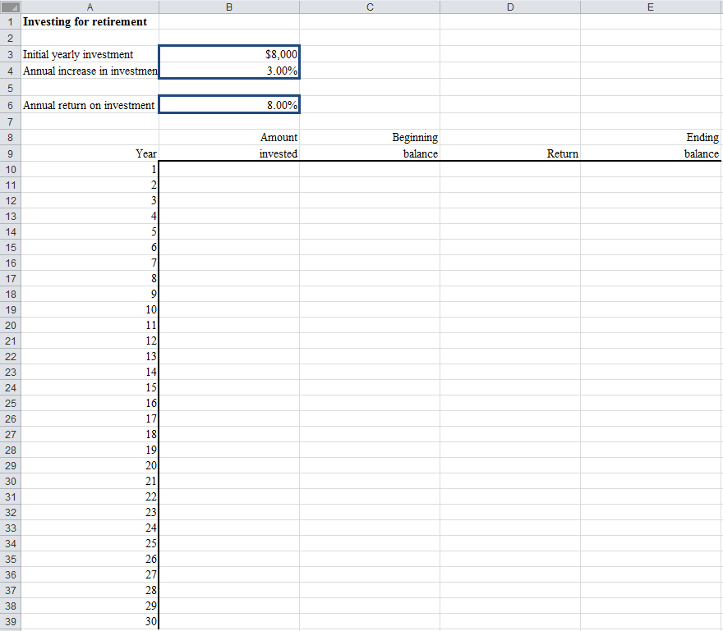

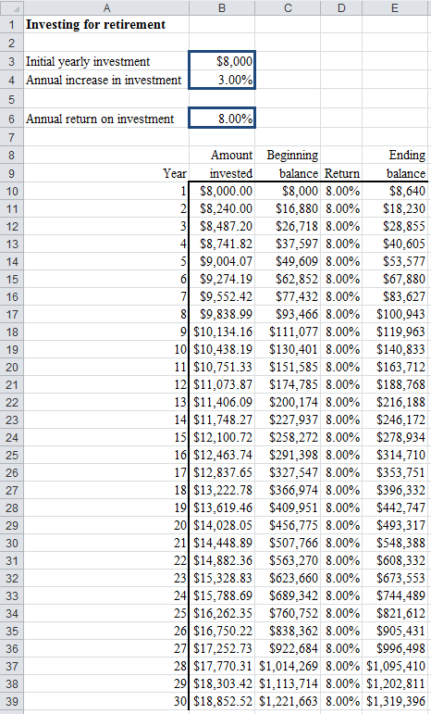**Model 1 Results:**

Problem?

______________________________________________________________________________

**Model 2: Suppose the annual return on stocks follows a *normal distribution* with a mean of 8% and a standard deviation of 25%.**

|  |
| --- |
|  |
| … |
|  |

Step 1: Loading @Risk.

Step 2: Revise Excel worksheet.

Step 3: Specify *output cells*.

Step 4: Choose simulation settings.

Iterations = ____________

Simulations = ____________

Step 5: Run simulation.

Step 6: Examine the results.

**Model 2 Results:**

One particular simulation result for Model 2:

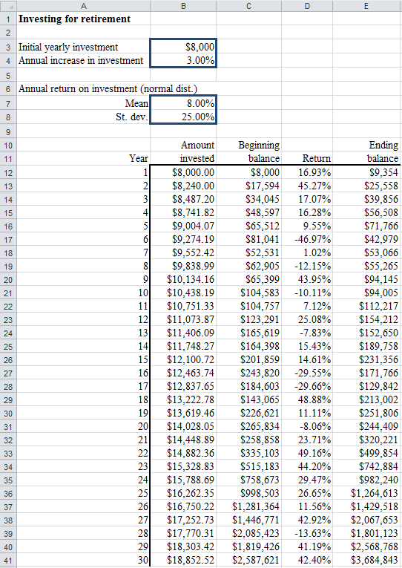

@Risk output for Model 2:

|  |
| --- |
| Browse results: |
|  |
| Simulation Detailed Statistics: |
|  |
| … |
|  |

Question: What’s the probability of getting a final balance of more than $1,000,000?

**Model 3: Examine a strategy to invest at 8% if balance is <$1,000,000. Stop investing if balance is >=$1,000,000. Calculate the probability of achieving target of $1,000,000.**

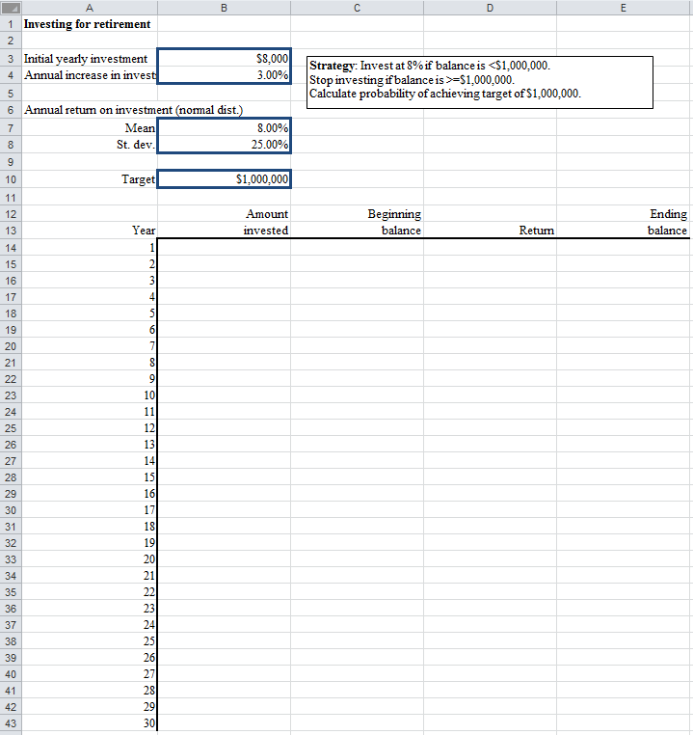

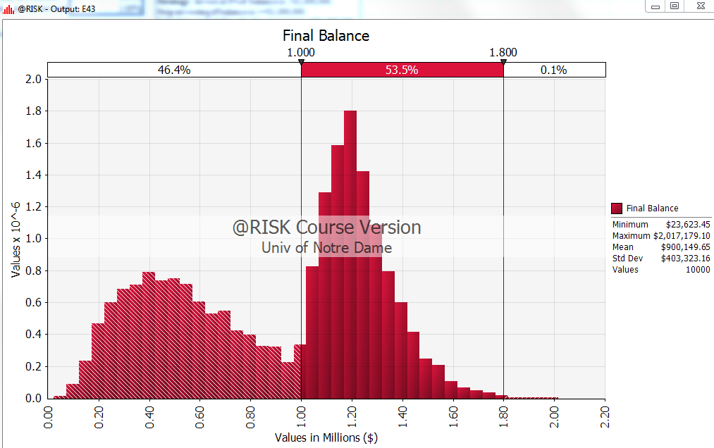@Risk output for Model 3:

Question: What is the probability of achieving target of $1,000,000?